# Introduction

Project Title: Cryptoverse Team

**TEAM MEMBERS: 4**

|  |  |
| --- | --- |
| **TEAM ID** | **SWTID1741150814** |
| **TEAM LEADER** | **H PAVITHRA** |
| **TEAM MEMBER** | **M YOGALAKSHNI** |
| **TEAM MEMBER** | **M SANGEETHA** |
| **TEAM MEMBER** | **A PRIYA** |

# Project Overview

Purpose:

The **Cryptoverse** project aims to provide a **user-friendly, real-time cryptocurrency tracking platform** that enables users to **analyze, compare, and stay updated** with market trends. It is designed for both **beginners and experienced traders**, offering comprehensive data visualization and insights to make informed decisions.

Features:

* Live cryptocurrency price tracking
* Historical price data visualization
* Interactive charts and graphs
* User authentication
* News updates

# Architecture

Component Structure:

* Header: Navigation bar
* Dashboard: Live market data
* Crypto Details: Individual cryptocurrency info
* Portfolio: User holdings tracking
* News Section: Real-time updates

State Management:

Using Redux Toolkit

Routing:

React Router with paths: Home (/), Crypto Details (/crypto/:id), Portfolio (/portfolio), News (/news)

# Setup Instructions

Prerequisites:

* Node.js
* npm or yarn
* React.js
* Redux Toolkit

Installation:

1. Clone repository: git clone https://github.com/your-repo/cryptoverse.git
2. Install dependencies: npm install
3. Configure environment variables

# Folder Structure

/cryptoverse

|----/src

|---- /components

|---- /pages

|---- /redux

|---- /utils

|---- /assets

|---- package.json

|----README.md

**Running the Application** To start development server: npm start

# Component Documentation

Key Components:

* CryptoCard: Cryptocurrency overview
* PriceChart: Historical price data
* NewsFeed: Crypto news **Reusable Components:**
* Button: Customizable
* Loader: Loading animations

# State Management

Global State: Managed using Redux Toolkit Local State: Managed with React?s useState

# Styling

Using Tailwind CSS with a custom theme for a modern UI

# Testing

Testing Strategy:

* Unit Testing: Jest & React Testing Library
* Integration Testing: Cypress for E2E tests

|  |
| --- |
| **Screenshots** |
|  |

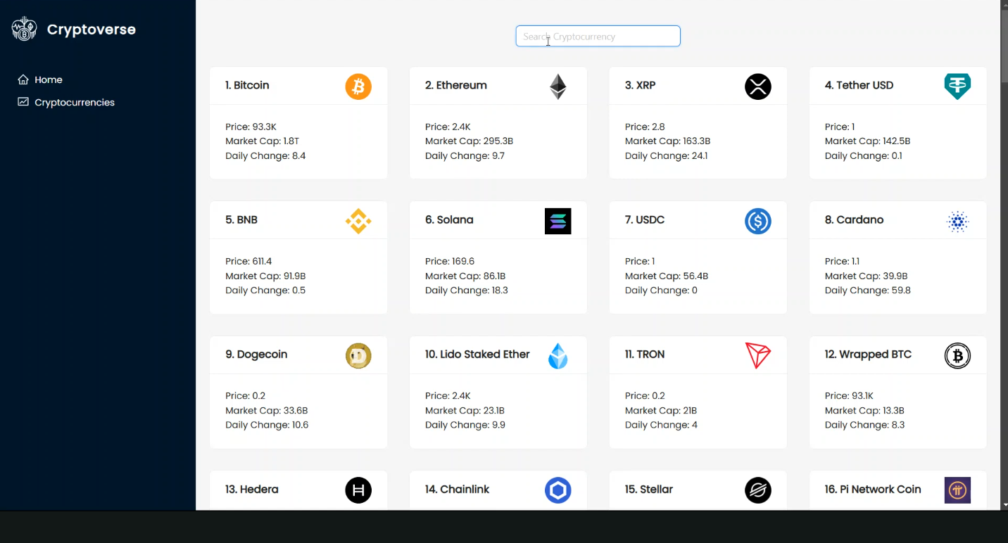

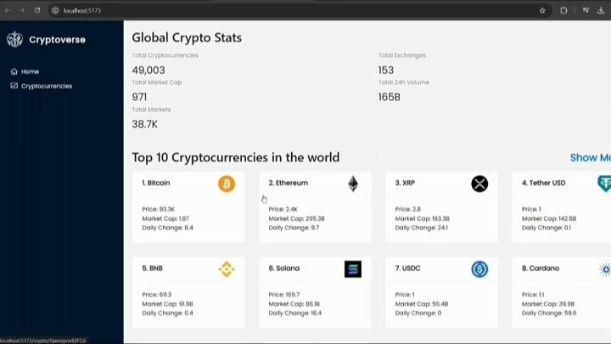

# Known Issues

API rate limits may affect updates. Dark mode support in progress.

# Future Enhancements

Future Plans:

* Push notifications for price alerts
* AI-driven price predictions
* Staking feature for rewards

**Security Considerations**Ensuring the security of user data and transactions is a critical aspect of Cryptoverse.

1. Secure API Communication: All API requests use HTTPS for encryption.

2. Authentication & Authorization: JWT tokens are used for secure authentication.

3. Rate Limiting: Prevents abuse by restricting excessive API requests.

4. Data Encryption: Sensitive user data is encrypted before storage.

5. Regular Security Audits: Routine security tests to identify vulnerabilities.

**Performance Optimizations**

To ensure smooth performance and fast load times, the following optimizations are applied:

1. Lazy Loading: Loads components only when needed, reducing initial load time.

2. Code Splitting: Uses Webpack for splitting bundles and optimizing resource usage.

3. Caching Strategies: Implements caching mechanisms for API responses.

4. Database Indexing: Ensures faster queries when fetching cryptocurrency data.

**Use Cases:**

Cryptoverse is useful for different types of users, including:

1. Crypto Investors: Helps users track price changes and market trends.

2. Traders: Provides real-time data, making it easier to buy/sell at the right time.

3. Beginners: Offers an intuitive platform to learn about cryptocurrencies.

4. Analysts: Enables professionals to analyze market patterns through historical data.

**Troubleshooting Guide:**

Below are common issues users may encounter and their solutions:

1. App Not Loading: Ensure that the backend API is running and environment variables are set correctly.

2. Slow Performance: Check internet connection and clear browser cache.

3. Authentication Issues: Verify login credentials and reset password if needed.

4. Data Not Updating: API rate limits might be exceeded, try again later.